ATTACHED 4, PORTRAIT OF ATHENS,EATING AND TAVERN GUIDE OF ATHENS
PORTRAIT OF ATHENS
- ATTRACTIONS OF ATHENS,GREECE
SOUCE : WIKIPEDIA
https://en.wikipedia.org/wiki/Athens
Athens is recognised as a global city because of its location and its importance in shipping, finance, commerce, media, entertainment, arts, international trade, culture, education and tourism. It is one of the biggest economic centres in southeastern Europe, with a large financial sector, and its port Piraeus is both the largest passenger port in Europe^{[11][12][13][14]} and the second largest in the world.^{[15]}

The heritage of the classical era is still evident in the city, represented by ancient monuments and works of art, the most famous of all being the Parthenon, considered a key landmark of early Western civilization. The city also retains Roman and Byzantine monuments, as well as a smaller number of Ottoman monuments.
Athens is home to two UNESCO World Heritage Sites, the Acropolis of Athens and the medieval Daphni Monastery. Landmarks of the modern era, dating back to the establishment of Athens as the capital of the independent Greek state in 1834, include the Hellenic Parliament and the so-called "architectural trilogy of Athens", consisting of the National Library of Greece, the National and Kapodistrian University of Athens and the Academy of Athens. Athens was the host city of the first modern-day Olympic Games in 1896, and 108 years later it welcomed home the 2004 Summer Olympics.^{[20]} Athens is also home to several large museums, such as the National Archeological Museum, featuring the world's largest collection of ancient Greek antiquities, the Byzantine and Christian Museum and the new Acropolis Museum.

Climate
Athens has a hot-summer Mediterranean climate (Köppen Csa). The dominant feature of Athens's climate is alternation between prolonged hot and dry summers and mild winters with moderate rainfall.^{[33]} With an average of 414.1 millimetres (16.30 in) of yearly precipitation, rainfall occurs largely between the months of October and April. July and August are the driest months, where thunderstorms occur sparsely once or twice a month. Winters are mild and rainy, with a January average of near 10 °C (50 °F);

Architecture
Athens incorporates architectural styles ranging from Greco-Roman and Neoclassical to modern. They are often to be found in the same areas, as Athens is not marked by a uniformity of architectural style.

Plaka, Monastiraki, and Thission – Plaka (Greek: Πλάκα), lying just beneath the Acropolis, is famous for its plentiful neoclassical architecture, making up one of the most scenic districts of the city. It remains a prime tourist destination with tavernas, live performances and street salesmen. Nearby Monastiraki (Greek: Μοναστηράκι), for its part, is known for its string of small shops and markets, as well as its crowded flea market and tavernas specialising in souvlaki. Another district known for its student-crammed, stylish cafés is Theseum or Thission (Greek: Θησείο), lying just west of Monastiraki. Thission is home to the ancient Temple of Hephaestus, standing atop a small hill. This area also has a picturesque 11th-century Byzantine church, as well as a 15th-century Ottoman mosque.

Culture and contemporary life

Archaeological hub
The city is a world centre of archaeological research. Along with national institutions, such as the Athens University and the Archaeological Society, there are multiple archaeological Museums including the National Archaeological Museum, the Cycladic Museum, the Epigraphic Museum, the Byzantine & Christian Museum, as well as museums at the ancient Agora, Acropolis, Kerameikos, and the Kerameikos Archaeological Museum. The city is also home to the Demokritos laboratory for Archaeometry, alongside regional and national archaeological authorities that form part of the Greek Department of Culture.
Athens hosts 17 Foreign Archaeological Institutes which promote and facilitate research by scholars from their home countries. As a result, Athens has more than a dozen archaeological libraries and three specialized archaeological laboratories, and is the venue of several hundred specialized lectures, conferences and seminars, as well as dozens of archaeological exhibitions, each year. At any given time, hundreds of international scholars and researchers in all disciplines of archaeology are to be found in the city.

Museums
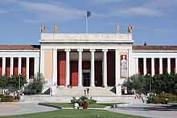
The National Archaeological Museum in central Athens
Athens' most important museums include:
- the National Archaeological Museum, the largest archaeological museum in the country, and one of the most important internationally, as it contains a vast collection of antiquities; its artifacts cover a period of more than 5,000 years, from late Neolithic Age to Roman Greece;
- the Benaki Museum with its several branches for each of its collections including ancient, Byzantine, Ottoman-era, and Chinese art and beyond;
- the Byzantine and Christian Museum, one of the most important museums of Byzantine art;
- the Numismatic Museum, housing a major collection of ancient and modern coins;
- the Museum of Cycladic Art, home to an extensive collection of Cycladic art, including its famous figurines of white marble;
- the New Acropolis Museum, opened in 2009, and replacing the old museum on the Acropolis. The new museum has proved considerably popular; almost one million people visited during the summer period June–October 2009 alone. A number of smaller and privately owned museums focused on Greek culture and arts are also to be found.
- the Kerameikos Archaeological Museum, a museum which displays artifacts from the burial site of Kerameikos. Much of the pottery and other artifacts relate to Athenian attitudes towards death and the afterlife, throughout many ages.
- the Jewish Museum of Greece, a museum which describes the history and culture of the Greek Jewish community.

Tourism
Athens has been a destination for travellers since antiquity. Over the past decade, the city's infrastructure and social amenities have improved, in part because of its successful bid to stage the 2004 Olympic Games. The Greek Government, aided by the EU, has funded major infrastructure projects such as the state-of-the-art Eleftherios Venizelos International Airport,^{[83]} the expansion of the Athens Metro system,^{[65]} and the new Attiki Odos Motorway.^{[65]}
Athens was voted as the third best European city to visit in 2015 by European Best Destination. More than 240,000 people voted.

Entertainment and performing arts
Athens is home to 148 theatrical stages, more than any other city in the world, including the ancient Odeon of Herodes Atticus, home to the Athens Festival, which runs from May to October each year.^{[84][85]} In addition to a large number of multiplexes, Athens plays host to open air garden cinemas. The city also supports music venues, including the Athens Concert Hall (Megaron Moussikis), which attracts world class artists.^{[86]} The Athens Planetarium,^{[87]} located in Andrea Syngrou Avenue, is one of the largest and best equipped digital planetaria in the world.^{[88][89]} The Stavros Niarchos Foundation Cultural Center, inaugurated in 2016, will house the National Library of Greece and the Greek National Opera.^{[90]}

Sports
Athens has a long tradition in sports and sporting events, serving as home to the most important clubs in Greek sport and housing a large number of sports facilities. The city has also been host to sports events of international importance.
Athens has hosted the Summer Olympic Games twice, in 1896 and 2004. The 2004 Summer Olympics required the development of the Athens Olympic Stadium, which has since gained a reputation as one of the most beautiful stadiums in the world, and one of its most interesting modern monuments.^{[91]} The biggest stadium in the country, it hosted two finals of the UEFA Champions League, in 1994 and 2007. Athens' other major stadium, located in the Piraeus area, is the Karaiskakis Stadium, a sports and entertainment complex, host of the 1971 UEFA Cup Winners' Cup Final. In 2004 Greece national football team won the UEFA European Championship Finals in Portugal. In the final tie they beat the host nation Portugal 1:0.

- THE 10 MORE ATTRACTIVE PLACES IN ATHENS

http://www.planetware.com/tourist-attractions-/athens-gr-ath-ath.htm

A symbol of Western Civilization at its most magnificent, Athens boasts an illustrious history that stretches back more than 3,000 years. The city flourished during classical antiquity and was the birthplace of Socrates, Pericles, and Sophocles. More than just a relic of its glorious past, today Athens is a bustling and modern capital city. A completely different vacation experience from the idyllic Greek islands, Athens can feel hectic and crowded but compensates with amazing cultural attractions. The Acropolis is one of the world's most breathtaking ancient ruins, and the city's exceptional archaeology museums display fascinating artifacts uncovered at local sites. Other hidden charms awaiting discovery are the dazzling Byzantine churches found all over the city and the village-like neighborhoods north of the Acropolis. Tourists will enjoy getting lost in the Plaka district's narrow pedestrian streets, lined with quaint bougainvillea-draped houses and inviting restaurant terraces.
See also: Where to Stay in Athens

1 The Acropolis
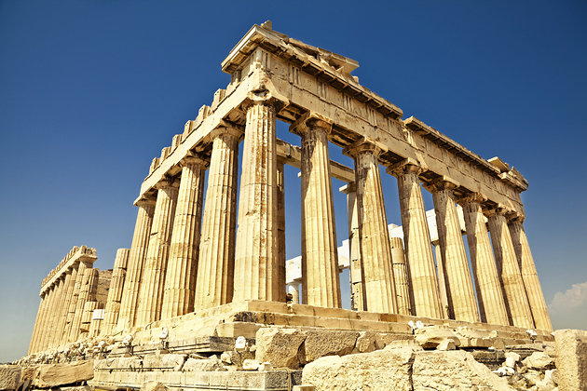
The Acropolis
Share:
Few sights in the world compare to Athen's Acropolis, with its Parthenon temple perched high on a rocky crag keeping watch over centuries of civilization. A reminder of the glory of ancient Athens, the Acropolis was the center of the ancient city and functioned as a citadel in its protected hilltop location. The most emblematic building is the Parthenon, the largest temple of the classical antiquity period dating from 447 BC to 338 BC. With its monumental rows of Doric columns and stunning sculptural details, the temple is an awe-inspiring sight. In the frieze on the eastern side, reliefs depict the birth of the goddess Athena. Other ruins of the Acropolis include the Erechtheion, a complex of ancient sanctuaries built between 421 BC and 395 BC. The most famous feature of the Erechtheion complex is the Porch of the Caryatids, with six statues of maidens in place of Doric columns.
Be sure to also visit the Acropolis Museum at 15 Dionysiou Areopagitou Street, below the Acropolis hilltop. This museum contains one of the most valuable collections of ancient Greek art in the world. Also nearby are two interesting neighborhoods, Plaka and Anafiotika, charming areas to stop for a meal and stroll around the picturesque pedestrian streets.

2 National Archaeology Museum
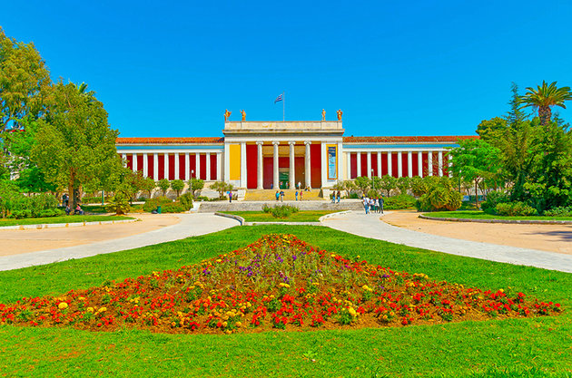
National Archaeology Museum
Share:
Founded in the 19th century, Athens' National Archaeological Museum is the largest archaeological museum in Greece and one of the greatest antiquities museums in the world. The museum is housed in an impressive Neoclassical building with 8,000 square meters of exhibition space. On display are five permanent collections with more than 11,000 exhibits, offering a comprehensive overview of Greek civilization from prehistory through the classical period to late antiquity. The Prehistoric Collection covers the sixth millennium BC to 1050 BC (the Neolithic, Cycladic, and Mycenaean periods) and presents findings from the prehistoric settlement at Thera. The Sculpture Collection exhibits ancient Greek sculptures from the sixth century BC to the fifth century BC, including rare masterpieces. The Vase and Decorative Objects Collection showcases ancient Greek pottery from the 11th century BC all the way until the classical Roman period. The Stathatos Collection features minor objects from a wide range of historical periods. Exquisite little statues and figurines sculpted from metals are on display in the Metallurgy Collection.
Address: 44 Patission Street, Athens
Official site: http://www.namuseum.gr/index-en.html

3 Byzantine Museum
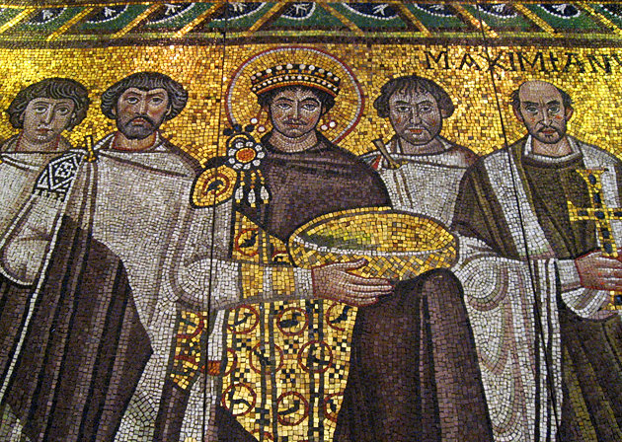
Byzantine Museum Fiona and Robert
Share:
This interesting museum offers fascinating insights into the Byzantine period of Greek history. Housed in a 19th-century palace originally built for the Duchesse de Plaisance, the wife of Charles-François Lebrun of France, the museum displays a precious collection of Byzantine art. The Byzantine Empire was the inheritance of the eastern half of the Roman Empire after it fell; the expansive empire was officially Orthodox Christian in religion and Greek speaking. From the third century to the 15th century, the Byzantine Empire ruled over the land of what is now the Balkans, Greece, and Asia Minor. During this time, religious art was highly valued. Byzantine artists created masterpieces of detailed glittering mosaics and gilded icons.
With more than 25,000 artifacts on display, the Byzantine Museum is a treasury of religious artifacts from the Byzantine period as well as pieces from the early Christian, medieval, and post-Byzantine eras. The collection includes sculptures, paintings, icons, textiles, and mosaics. Highlights are the architectural fragments from early Christian basilicas and Byzantine churches and the reproduction of a fountain depicted at the Monastery of Dafní. The museum's courtyard features a splendid fragment of a mosaic floor from the fifth century.
Address: 22 Vas. Sofias Avenue, Athens
Official site: www.byzantinemuseum.gr

4 Agora: Ruins of the Ancient Marketplace
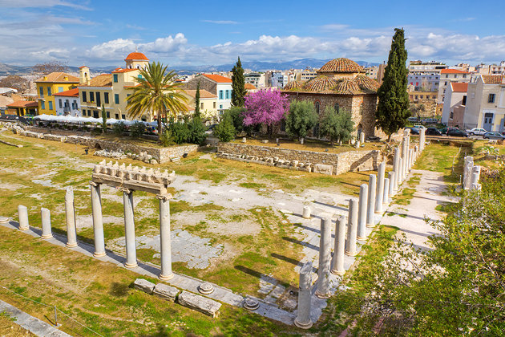
Agora: Ruins of the Ancient Marketplace
Share:
The ancient Agora was the marketplace and the center of everyday life in ancient Athens. For an impressive view of the Agora from afar, head to the north wall of the Acropolis or the roads from the Areopagus. The best place to enter the Agora is at the north gate off Adrianoú Street (near the Church of Saint Philip). The Greek word "Agora" means to "gather and orate," indicating that this site was a location of public speaking. The Agora was a place of administration and commerce as well as the meeting place of the Agora tou Dimou, a civic decision-making group. Athletic events and theater performances were also held here. One particularly interesting feature of the Agora is the 18-meter-long Royal Stoa, the seat of the Archon Basileus, who took over the cultic functions of the earlier kings. This sixth-century BC stoa may have been the scene of Socrates' trial in 399 BC.
From the Agora, tourists can take a pleasant walk along the footpath that leads up the Agora Hill (Kolonos Agoraios). On the hilltop at 24 Andrianou Street is an awe-inspiring sight, the Temple of Hephaistos. This fifth-century BC Doric temple is one of the best-preserved ancient Greek temples, thanks to its conversion into a Christian church, which saved it from destruction. The temple was designed on a classical plan with six rows of 13 columns, and the Ionic friezes appear to be modeled on the Parthenon. Across from the Roman Agora, only 16 meters away, is the site of the ancient Library of Hadrian, a complex of buildings founded by Emperor Hadrian after AD 132.
Address: 24 Andrianou Street, Athens

5 Museum of Cycladic Art
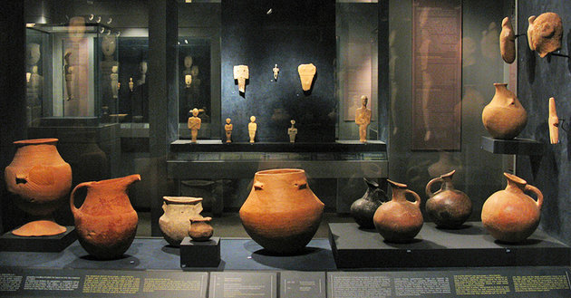
Museum of Cycladic Art Tilemahos Efthimiadis
Share:
In the Kolonáki quarter, the Museum of Cycladic Art was created in 1986 by the Nicholas and Dolly Goulandris Foundation. The shipowner Nikolas P. Goulandris was a well-known patron of the arts and cultural life in Athens. Goulandris' own collection forms the core of the museum's exhibits. Housed in a sleek modern building with a facade of marble and glass, the museum's permanent collection includes more than 3,000 objects. The collection represents ancient Greek art, ancient art of the Cyclades (the islands in the Aegean Sea encircling the Island of Delos near Mykonos), and Cypriot art (from the island of Cyprus) dating from the fourth century BC to the sixth century AD. Many of the artifacts on display date to the sixth century BC. Temporary exhibits are held at the elegant 19th-century Stathatos Mansion, accessible from the main building by a passageway from the atrium.
Address: 4 Neophytou Douka Street, Athens
Official site: www.cycladic.gr

6 Church of the Holy Apostles
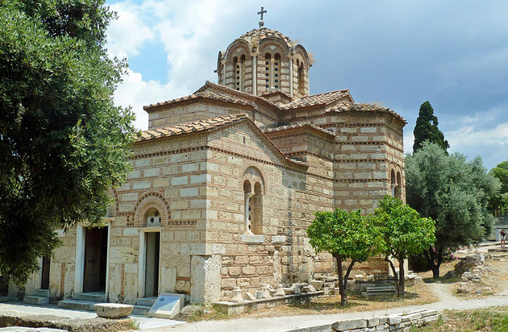
Church of the Holy Apostles
Share:
On the site of the ancient Agora, the Church of the Holy Apostles was the only building left standing when this entire quarter of Athens was demolished to excavate the Agora archaeological site. Built in the 10th century, the church stands above a nymphaion (sacred spring). The exterior is notable for its ashlar masonry and its ornamental Kufic (a style of Arabic script) inscriptions. Typical of Byzantine architecture, the church has a dome supported on four columns, and the apse and transepts feature semicircular conches. The interior of the dome is adorned with original frescoes depicting Christ Pantocrator (Ruler of All), John the Baptist, adorable little cherubim, and archangels. Much of the original 11th-century iconostasis (wall of icons and religious paintings) has also been well preserved.
Location: Ancient Agora, Athens

7 Panaghia Kapnikaréa Church
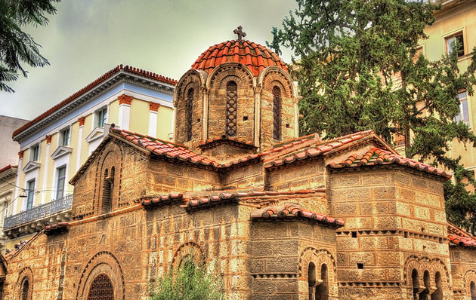
Panaghia Kapnikaréa Church
Share:
Gracing a little square that opens onto Ermoú Street, the Panaghia Kapnikaréa Church is a delightful place to visit. This beautiful little church was saved from demolition in the 19th century by the intervention of King Ludwig I of Bavaria. The church is a splendid example of architecture from the 11th-century Byzantine era. During this period, domed cruciform churches such as this one were typical. In the 12th century, the church was enhanced with a graceful entrance portico and a narthex featuring four pediments (built onto the western end). Inside, the church is decorated with 19th-century paintings created in the iconographic style of the Middle Byzantine period.
Location: Corner of Ermoú and Kalamiótous Street, Athens

8 Olympeion: Temple of Olympian Zeus
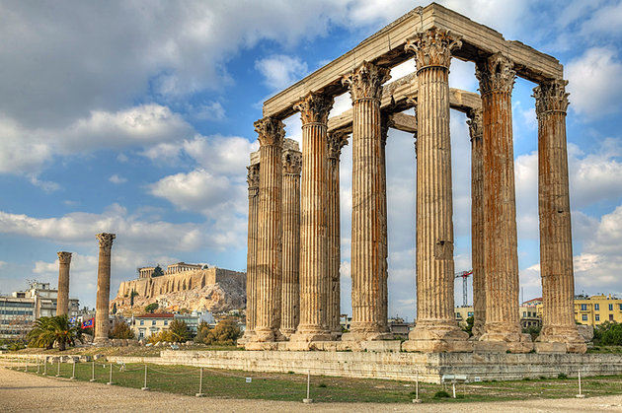
Olympeion: Temple of Olympian Zeus
Share:
Dedicated to Zeus, the Olympeion was the largest temple in ancient Greece. Though the Parthenon is better preserved, the Temple of Olympian Zeus was an even more monumental structure in its day. The temple dates to the sixth century BC but was not completed until the second century AD by the Emperor Hadrian. It's easy to imagine the grand impression this temple made in its complete form. More than a hundred enormous marble columns once supported the grandiose sanctuary. Only 15 columns remain standing, and another surviving column lies on the ground, but the ruins' monumental presence gives a sense of the massive size of the original building. The gigantic structure was a befitting shrine to Zeus, the ancient Greeks' most all-powerful God, known as the King of Gods. Nearby, just north of the Olympeion, is a small park containing the ruins of Themistokles' wall and the ancient Roman baths.
Location: City Center near the Athens Gate and Athanasiou Diakou Street, Athens

9 Panathenaic Stadium & Olympic Stadium
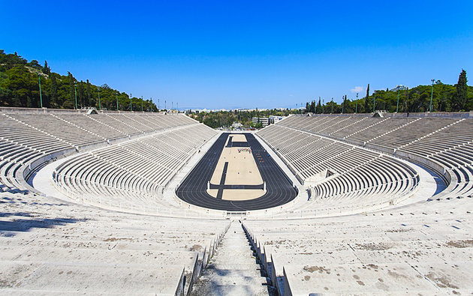
Panathenaic Stadium & Olympic Stadium
Share:
Ancient Athens's largest building, the Panathenaic Stadium, has a capacity for 60,000 spectators. Constructed around 335 BC during the era of Herodes Atticus, the venue hosted the Panathenaic Games where runners competed in races around the track. The 204-meter-long track was designed with four double herms, where runners would turn in the races. Around AD 140, the stadium was updated with new marble seating by Herodes Atticus. The structure that tourists see today is a replica of the original stadium, which was rebuilt for the Olympic Games of 1896. This modern-era Olympic Stadium was created in the identical fashion as the Panathenaic Stadium, with 47 tiers of seating and a rounded southeast end.
Location: Ardettos Hill, Athens

10 The Charming Neighborhoods of Plaka and Anafiotika
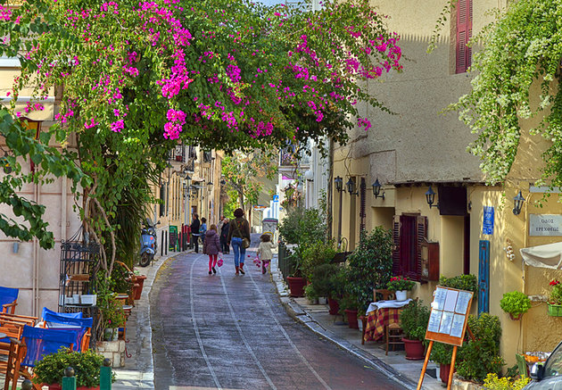
The Charming Neighborhoods of Plaka and Anafiotika
Share:
Between the northern slopes of the Acropolis and Ermoú Street, the picturesque Pláka neighborhood boasts two important archaeological sites on Pepopida Street: the first-century BC Roman Agora and the second-century Library of Hadrian. However, the main attraction of this historic area is its charming village ambience. Narrow pedestrian streets and the cheerful little squares of the Pláka quarter are lined with lovely bougainvillea-trimmed pastel-painted houses. Tucked away in peaceful corners of the neighborhood are historic churches, such as the Metamórfosis Church in the southwest and the Church of Kapnikaréa in the north. The picturesque setting invites leisurely strolls.
The Plaka quarter has an abundance of authentic Greek restaurants with inviting terrace seating. The area is famous for its Restaurant Staircase on Mnisikleous Street. Many of the restaurants look enticing but most are tourist traps (with aggressive hosts baiting passersby to enter) and should be avoided. Consult a guidebook or ask a local for recommendations before choosing a restaurant in this area, or instead try the quieter streets hidden away on the hillside, which conceal cute little cafés and tavernas. Also nestled into the slopes north of the Acropolis is Anafiotika, another atmospheric village-like neighborhood where tourists can enjoy a traditional Greek meal. The winding medieval streets of this Anafiotika are also a delight to explore.

Where to Stay in Athens for Sightseeing
The best place to stay in Athens is near the Acropolis in the Plaka or Anafiotika neighborhoods. This will put you in the center of the action and within walking distance of the Acropolis, Roman Agora, Library of Hadrian, and Syntagma Square. Both neighborhoods are picturesque and quaint, with narrow pedestrian-only streets, many restaurants, and interesting shops. Below are some highly-rated hotels in convenient locations:
- Luxury Hotels: Within walking distance from the Temple of Olympian Zeus and many good restaurants, the boutique AVA Hotel Athens offers quaint and cozy suites with kitchenettes. The O&B Athens Boutique Hotel is a 10-minute walk to the Acropolis and features modern rooms and a spectacular rooftop patio with amazing views. The elegant Grande Bretagne Hotel, with a well-regarded rooftop restaurant, is set in a prime location that it has occupied since 1874.
- Mid-Range Hotels: The appropriately named Plaka Hotel offers good rooms in a great location, and the rooftop patio has views to the Acropolis. Free coffee and tea are on offer all day long. The Hermes Hotel in the Plaka is newly renovated and just a two-minute walk to the attractions of Syntagma Square. On a quiet side street, the Central Hotel has also been recently renovated and offers modern, comfortable rooms and a hot breakfast. It's a 15-minute walk from the Acropolis, and the view from the rooftop patio is quite spectacular.
- Budget Hotels: The Hotel Acropolis House is a good value option close to all the attractions. Basic but comfortable rooms are on offer, and the shops of the pedestrian-only Ermou Street are a short stroll away. The Kimon Athens Hotel features small but well-appointed rooms and is a two-minute walk from Syntagma Square. The Hotel Metropolis has been recently renovated and provides rooms with balconies, some facing the Acropolis.

Tips and Tours: How to Make the Most of Your Visit to Athens
- See the Sights: For maximum sightseeing flexibility and value, it's hard to beat the City Sightseeing Athens Hop-On Hop-Off Tour. Accompanied by an audio commentary, you can cruise around Athens in an open-top double decker bus, hopping on and off at any of the 14 stops to spend more time at your favorite attractions, such as the Acropolis or the Plaka. If you only have a few hours to see the highlights of Athens, the Athens Half-Day Sightseeing Tour blends both the city's ancient and modern attractions. An expert guide takes you to see top sites such as the Tomb of the Unknown, the Acropolis, and the Pantheon. This 3.5-hour tour includes admission to the Acropolis of Athens and the Acropolis Museum (optional), hotel pickup, and free Wi-Fi on the coach.
- Delphi Day Trip: If you want to complement your Athens tour by exploring historic monuments further afield, consider the Delphi Day Trip. This full-day tour takes you to this World Heritage-listed archaeological site to see the Temple of Apollo and the Delphi Archeological Museum. On your way home, you have a chance to explore the picturesque towns of Arachova and Levadia. Included in the tour are hotel pickup and drop-off at select hotels, free Wi-Fi, and entrance fees.
- Mycenae and Epidaurus Day Trip: Stunning scenery and hilltop ruins are the highlights of the Mycenae and Epidaurus Day Trip. This full-day guided adventure includes a beautiful drive along the Saronic Gulf and into the Peloponnese to see the hilltop ruins of Mycenae as well as a visit to Epidaurus, the birthplace of Apollo's son, and the picturesque town of Nauplia. Also included are entrance fees, a professional guide, free Wi-Fi on the coach, and a map.
- Cape Sounion and Temple of Poseidon Day Trip: See one of Athens' most famous monuments on the Cape Sounion and Temple of Poseidon Half-Day Trip. Traveling in an air-conditioned coach, you can sit back, relax, and enjoy a scenic drive to Cape Sounion to see the remains of the clifftop Temple of Poseidon, overlooking the sea, while an experienced guide shares information about its history. This four-hour tour includes hotel pickup and drop-off at select hotels, entrance fees, and free Wi-Fi on the coach.

EATING AND TAVERN GUIDE OF ATHENS

Greek cuisine and the best taverns to eat in Athens
From Wikipedia, the free encyclopedia
https://en.wikipedia.org/wiki/Greek_cuisine
Greek cuisine is a Mediterranean cuisine.^{[1]} It has some common characteristics with the traditional cuisines of Italy, and the Balkans.
Contemporary Greek cookery makes wide use of vegetables, olive oil, grains, fish, wine, and meat (white and red, including lamb, poultry, rabbit and pork). Other important ingredients include olives, cheese, eggplant (aubergine), zucchini (courgette), lemon juice, vegetables, herbs, bread and yoghurt. The most commonly used grain is wheat; barley is also used. Common dessert ingredients include nuts, honey, fruits, and filo pastry.
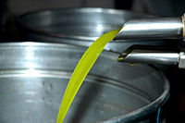
Greek olive oil
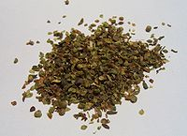
Dried oregano for culinary use
The most characteristic and ancient element of Greek cuisine is olive oil, which is used in most dishes. It is produced from the olive trees prominent throughout the region, and adds to the distinctive taste of Greek food; however, they are also widely eaten. The basic grain in Greece is wheat, though barley is also grown. Important vegetables include tomato, aubergine (eggplant), potato, green beans, okra, green peppers, and onions. Honey in Greece is mainly honey from the nectar of fruit trees and citrus trees: lemon, orange, bigarade (bitter orange) trees, thyme honey, and pine honey. Mastic (aromatic, ivory coloured resin) is grown on the Aegean island of Chios.
Greek cuisine uses some flavorings more often than other Mediterranean cuisines do, namely: oregano, mint, garlic, onion, dill and bay laurel leaves. Other common herbs and spices include basil, thyme and fennel seed. Parsley is also used as a garnish on some dishes. Many Greek recipes, especially in the northern parts of the country, use "sweet" spices in combination with meat, for example cinnamon, whole spice and cloves in stews.
The climate and terrain has tended to favour the breeding of goats and sheep over cattle, and thus beef dishes are uncommon. Fish dishes are common in coastal regions and on the islands. A great variety of cheese types are used in Greek cuisine, including Feta, Kasseri, Kefalotyri, Graviera, Anthotyros, Manouri, Metsovone, Ladotyri (cheese with olive oil), Kalathaki (a specialty from the island of Limnos), Katiki-Tsalafouti (both creamy cheeses, suitable for spreads) and Mizithra.
Too much refinement is generally considered to be against the hearty spirit of the Greek cuisine, though recent trends among Greek culinary circles tend to favour a somewhat more refined approach.
Dining out is common in Greece, and has been for quite some time. The Taverna and Estiatorio are widespread, serving home cooking at affordable prices to both locals and tourists. Recently, fast food has become more widespread, with local chains such as Goody's springing up, though most McDonald's have closed.^{[9]} Locals still largely eat Greek cuisine.^{[10]} In addition, some traditional Greek foods, especially souvlaki, gyros, pita such as tyropita and spanakopita (respectively, cheese and spinach pie) are often served in fast food style.

Origins
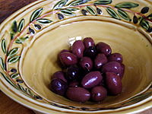
Kalamata olives
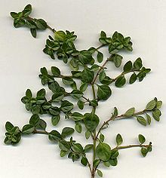
Thyme, one of the most traditional Greek herbs, was mentioned in the Odyssey.
Greece has an ancient culinary tradition dating back several millennia, and over the centuries Greek cuisine has evolved and absorbed numerous influences and influenced many cuisines itself.
Some dishes can be traced back to ancient Greece: lentil soup, fasolada, retsina (white or rosé wine flavored with pine resin) and pasteli (candy bar with sesame seeds baked with honey); some to the Hellenistic and Roman periods: loukaniko (dried pork sausage); and Byzantium: feta cheese, avgotaraho (cured fish roe) and paximadi (traditional hard bread baked from corn, barley and rye). There are also many ancient and Byzantine dishes which are no longer consumed: porridge as the main staple, fish sauce, and salt water mixed into wine.
Many dishes are part of the larger tradition of Greek cuisine: moussaka, tzatziki, yuvarlakia, keftethes, boureki, and so on.

Typical dishes
Greek cuisine is very diverse and although there are many common characteristics amongst the culinary traditions of different regions within the country, there are also many differences, making it difficult to present a full list of representative dishes. For example, the vegetarian dish "Chaniotiko Boureki" (oven baked slices of potatoes with zucchini, myzithra cheese and mint) is a typical dish in western Crete, in the region of Chania. A family in Chania may consume this dish 1-2 times per week in the summer season. However, it is not cooked in any other region of Greece. Many food items are wrapped in Filo pastry, either in bite-size triangles or in large sheets: kotopita (chicken pie), spanakotyropita (spinach and cheese pie), chortopita (greens pie), kreatopita (meat pie, using minced meat), kolokythopita (zucchini pie) etc. The Greeks do with filo what the Italians do with pizza; They have countless variations of pitas (savory pies). Even the word pita was originally spelled πίττα (pitta), which shows a similarity to pizza. The areas with the largest tradition of making Greek pitas are the North-Western (Hepirus) and Central Greece (also called Roumeli). Also, a big part of the Greek Cuisine are seeds and nuts. Seeds and nuts are included in everything from pastry to main dishes.^{[11]}
The list will present some of the most representative Greek dishes that can be found throughout the country and the most famous of the local ones:

Breads
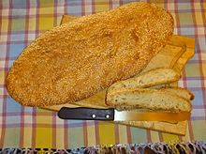
Lagana, a type of bread
- Daktyla
- Eliopsomo, bread with olives
- Paximadi, Cretan bread
- Karydopsomo, bread with walnuts
- Lagana
- Pita
- Stafidopsomo, bread with raisin

Appetizers and salads
Meze or orektiko (appetizer; plural mezedes/orektika) is served in restaurants called mezedopoleía, served to complement drinks, and in similar establishments known as tsipourádika or ouzerí (a type of café that serves drinks such as ouzo or tsipouro). A tavérna (tavern) or estiatório (restaurant) also offers a meze as an orektikó (appetiser). Many restaurants offer their house pikilía (variety) a platter with a smorgasbord of various mezedes that can be served immediately to customers looking for a quick or light meal. Hosts commonly serve mezedes to their guests at informal or impromptu get-togethers as they are easy to prepare on short notice. Krasomezédhes (literally "wine-meze") are mezedes that go well with wine; ouzomezédhes are mezedes that go with ouzo.
- Bakaliaros
- Deep-fried vegetables "tiganita" (courgettes/zucchini, aubergines, peppers, or mushrooms).
- Dakos, a Cretan salad consisting of a slice of soaked dried bread or barley rusk (paximadi) topped with chopped tomatoes and crumbled feta or mizithra cheese.
- Dolmadakia ( dolma): grapevine leaves stuffed with rice and vegetables; meat is also often included.
- Fava: purée of yellow split peas or beans; sometimes made of fava beans (called κουκιά in Greek). In Santorini made from yellow lentils.
- Garides Saganaki: shrimp in spicy tomato sauce with feta cheese.
- Gavros: european anchovy.
- Greek salad: the so-called Greek salad is known in Greece as village/country salad (horiatiki) and is essentially a tomato salad with cucumber, red onion, feta cheese, and kalamata olives, dressed with olive oil. In Cyprus it contains also cracked wheat (bulgur), spring onions instead of red onions, and lemon juice.
- Horta: wild or cultivated greens, steamed or blanched and made into salad, simply dressed with lemon juice and olive oil. They can be eaten as a light meal with potatoes (especially during Lent, in lieu of fish or meat).
- Kalamarakia: deep-fried squid.
- Kalamata olives
- Kalitsounia, appetizer from Crete
- Kaparosalata (salad with caper)
- Katsouni, cucumber from Santorini
- Kolokythakia: zucchini.
- Kolokythoanthoi: zucchini flowers stuffed with rice or cheese and herbs.
- Koukia: fava beans.
- Kroketes: croquettes.
- Lachanosalata: cabbage salad. Very finely shredded cabbage with salt, olive oil, lemon juice/vinegar dressing. Often combined with finely shredded carrot.
- Lakerda, a pickled bonito dish
- Macedonia salad
- Maintanosalata (salad with parsley)
- Marides tiganites: deep-fried whitebait, usually served with lemon wedges.
- Melitzanes, eggplants. Notable is the white eggplant from Santorini.
- Melitzanosalata: eggplant (aubergine) based dip.
- Pantzarosalata: beetroot salad with olive oil and vinegar.
- Patatosalata: potato salad with olive oil, finely sliced onions, mayonnaise, lemon juice or vinegar.
- Red Peppers of Florina
- Saganaki: fried yellow cheese, usually graviera cheese; the word "saganaki" means a small cooking pan, is used to say "fried" and can be applied to many other foods.
- Skordalia: thick garlic and potato puree, usually accompanies deep fried fish/cod (bakaliaros skordalia, i.e. fried battered cod with garlic dip, a very popular dish).
- Spanakopita: spinach, feta (sometimes in combination with ricotta cheese), onions or scallions, egg and seasoning wrapped in phyllo pastry in a form of a pie.
- Taramosalata: fish roe mixed with boiled potatoes or moistened breadcrumbs, olive oil and lemon juice.
- Tirokafteri, cheese spread.
- Tonosalata, tuna salad
- Tzatziki: yogurt with cucumber and garlic puree, used as a dip. Served with warm pita bread.)
- Tyropita: a white cheese (usually feta) pie with phyllo pastry. When yellow cheese (usually kasseri) is used, it is called Kasseropita.
Also, several pitas found all over Greece, such as Kolokythopita, Mizithropita (Crete), Melintzanopita, Tsouknidopita, Kremydopita, Kreatopita (meat pie), Galatopita, Marathopita, Malathropita (Chios), Ladopita.
- 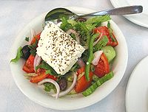
Classic Greek salad
- 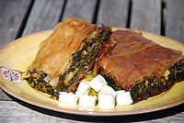
Spanakopita with cubed feta
- 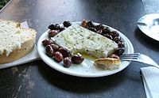
Simple meze of feta cheese and olives: characteristic Greek flavours
- 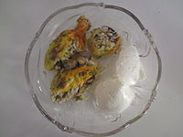
Kolokythoanthoi are often served with a dollop of Greek yogurt on the side.
- 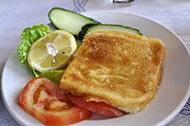
Saganaki
- 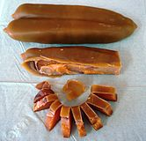
Botargo (Avgotaraho)

Soups
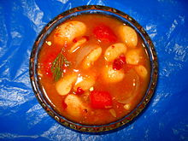
Fasolada
- Bourou-bourou, a vegetable and pasta soup from the island of Corfu
- Fakes, a lentil soup, usually served with vinegar and olive oil.
- Fasolada, a white-bean soup defined in many cookery books as the traditional Greek dish, sometimes even called "the national food of the Greeks".^{[12]} It is made of beans, tomatoes, carrot and a generous amount of celery usually served with a variety of salty side dishes(like olives or anchovies).
- Giouvarlosoupa, a meatball and rice soup with avgolemono
- Kakavia, soup made from any variety of small local fish with the bones removed before serving
- Kotosoupa Avgolemono, chicken and rice soup with egg lemon sauce added
- Kremydosoupa, onion soup served with vinegar.
- Magiritsa, the traditional Easter soup made with lamb offal, lamb liver, lamb lung and sometimes mutton meat usually thickened with avgolemono.
- Patsas, a tripe soup.
- Psarosoupa 'fish soup' can be made with a variety of fish (usually kokkinopsaro) and several kinds of vegetables (carrots, parsley, celery, potatoes, onion), several varieties include the classic kakavia which is drizzled with olive oil.
- Revithia, a chickpea soup.
- Trahana soup, made from a dried grain-dairy substance and chicken fat.

Vegetarian main dishes
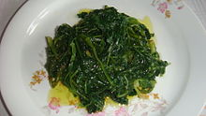
Boiled wild greens
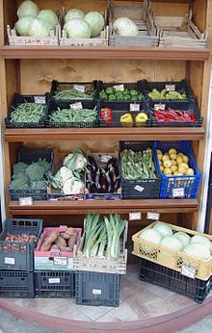
Traditional vegetable market
Very popular during fasting periods, such as the Great Lent:
- Anginares a la Polita:artichokes Constantinople style with artichoke hearts, olive oil, potatoes, carrots dill.
- Arakas me anginares: oven-baked fresh peas with artichokes.
- Bamies: okra with tomato sauce (sometimes with potatoes or during non-fasting times with chicken/lamb).
- Briám: an oven-baked ratatouille of summer vegetables based on sliced potatoes and zucchini in olive oil. Usually includes eggplant, tomatoes, onions, and ample aromatic herbs and seasonings.
- Fasolakia: fresh green beans stewed with potatoes, zucchini and tomato sauce.
- Gemista, baked stuffed vegetables. Usually tomatoes, peppers, or other vegetables hollowed out and baked with a rice-and-herb filling or minced meat.
- Gigandes plaki: large lima beans baked with tomato sauce and various herbs.^{[13]} Often made spicy with various peppers.
- Horta (greens), already mentioned in the appetizers section, are quite often consumed as a light main meal, with boiled potatoes and bread.
- Kinteata, dish made from boiled young nettles.
- Lachanorizo, cabbage with rice.
- Prassorizo, leeks with rice.
- Spanakorizo, spinach and rice stew cooked in lemon and olive-oil sauce.
- Tomatokeftedes: tomato fritters with mint, fried in olive oil and typically served with fava (split-pea puree). Mainly a Cycladic island dish.

Meat and seafood dishes
- Apáki: Cretan specialty; lean pork marinated in vinegar, then smoked with aromatic herbs and shrubs, and packed in salt.
- Astakos: lobster.
- Astakomacaronada: spaghetti with lobster.
- Atherina: fried smelts.
- Barbounia: red mullets.
- Bifteki: Ground beef burgers either baked, fried or grilled.
- Bourdeto: from Corfu.
- Chtapodi sti schara: grilled octopus in vinegar, oil and oregano. Accompanied by ouzo.
- Giouvetsi: lamb or veal baked in a clay pot with kritharaki (orzo) and tomatoes.
- Glossa: Sole (typically of the genus Solea)
- Gyros: meat (usually pork) roasted on a vertically turning spit and served with sauce (often tzatziki) and garnishes (tomato, onions) on pita bread, or served as a sandwich wrapped in pita bread together with tomatoes, onions, tzatziki and tomato sauce; a popular fast food.
- Kalamari: squid, most often fried.
- Kleftiko: literally meaning "in the style of the Klephts", this is lamb slow-baked on the bone, first marinated in garlic and lemon juice, originally cooked in a pit oven. It is said that the Klephts, bandits of the countryside who did not have flocks of their own, would steal lambs or goats and cook the meat in a sealed pit to avoid the smoke being seen.
- Keftedakia, fried meatballs.
- Kokkinisto, stew.
- Kokoretsi, Lamb or goat intestines wrapped around seasoned offal, including sweetbreads, hearts, lungs, or kidneys, and spit-roasted.
- Loukaniko, sausage
- Makaronia me kima, spaghetti noodles topped with saltsa kima^{[14]}
- Moussaka (from Arabic مسقعة musaqqa'): an oven-baked layer dish: ground meat and eggplant casserole, topped with a savory custard which is then browned in the oven. There are other variations besides eggplant, such as zucchini or rice, but the eggplant version, melitzánes moussaká is by far the most popular. The papoutsákia ("little shoes") variant is essentially the same dish, with the meat and custard layered inside hollowed, sauteéd eggplants.
- Mydia: mussels.
- Oven-baked lamb with potatoes (Αρνί στο φούρνο με πατάτες, Arní sto foúrna me patátes). One of the most common "Sunday" dishes. There are many variations with additional ingredients.
- Oven-baked chicken with potatoes (Κοτόπουλο στο φούρνο με πατάτες ''Kotópoulo sto foúrna me patátes). Another common "Sunday" dish.
- Paidakia: grilled lamb chops with lemon, oregano, salt and pepper.
- Pastitsada
- Pastitsio: an oven-baked layer dish: Béchamel sauce top, then pasta in the middle and ground meat cooked with tomato sauce at the bottom.
- Pork with celery (hirino me selino/hirino selinato).
- Savridia: mackerels oven-baked or fried.
- Sheftalia
- Sofrito, from Corfu
- Soupia: cuttlefish
- Soutzoukakia Smyrneika (Smyrna meatballs): long shaped meatballs with cumin, cinnamon and garlic and boiled in tomato sauce with whole olives. Often served with rice or mashed potatoes.
- Souvlaki: (lit: "skewer") grilled small pieces of meat (usually pork but also chicken or lamb) served on the skewer for eating out of hand, or served as a sandwich wrapped in pita bread together with tomatoes, onions, tzatziki and tomato sauce; a popular fast food, also called kalamaki (small reed) mainly in Athens.
- Spetsofai: a stew of country sausage, green mild peppers, onions and wine. Originates from Pelion.
- Stifado: rabbit or hare stew with pearl onions, vinegar, red wine and cinnamon. Beef can be substituted for game.
- Xiphias: swordfish.
- Yiouvarlakia: meatballs soup with egg-lemon sauce.
- 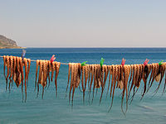
Octopuses are often sun-dried before grilling.
- 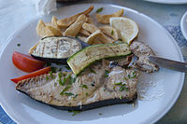
Swordfish dish
- 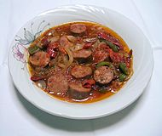
Spetsofai
- 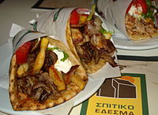
Pita with Gyros
- 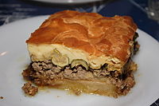
Moussaka
- 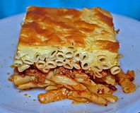
Pastitsio, an example of culinary influence from Italy (Venetian cuisine)

Quick meals
Meals easily available with inexpensive ingredients and little preparation involved.
- Hilopites pasta with chicken: savory chicken is mixed with "Hilopites" or cut up tile-shaped pasta in a spiced tomato sauce.
- Macaronada: classic spaghetti.
- Manestra
- Omeletta
- Strapatsada: eggs scrambled in olive oil and fresh tomato puree, seasoned with salt, pepper and oregano. Often includes feta cheese.

Desserts and sweets
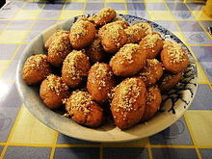
Melomakarona
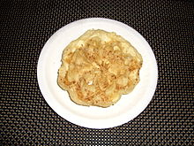
Diples are made on an iron mould dipped in batter and cooked in oil.
Melitinia cookies
- Amygdalopita: pie with almonds
- Amygdalotá or pastéli exist in many varieties throughout Greece and Cyprus, and are especially popular in the islands. They consist of powdered blanched almonds, confectioner's sugar and rose water, molded in various shapes and sizes. They are snow-white and are considered wedding and baptismal desserts.
- Copenhagen (dessert)
- Baklava, phyllo pastry layers filled with nuts and drenched in honey.
- Diples, a Christmas and wedding delicacy, made of paper-thin, sheet-like dough which is cut in large squares and dipped in a swirling fashion in a pot of hot olive oil for a few seconds. As the dough fries, it stiffens into a helical tube; it is then removed immediately and sprinkled with honey and crushed walnuts.^{[15]}
- Finikia, cookie topped with chopped nuts.
- Galaktoboureko, custard baked between layers of phyllo, and then soaked with lemon-scented honey syrup. The name derives from the Greek "gala"(γάλα), meaning milk, and börek, meaning filled, thus meaning "filled with milk".
- Halva
- Karydopita, a cake of crushed walnuts, soaked in syrup.
- Koulourakia, butter or olive-oil cookies.
- Kourabiedes, Christmas cookies made by kneading flour, butter and crushed roasted almonds, then generously dusted with powdered sugar.
- Lazarakia
- Loukoumades, similar to small crusty donuts, loukoumades are essentially fried balls of dough drenched in honey and sprinkled with cinnamon, typically served with sesame seed.
- Loukoumi is a confection made from starch and sugar. Patrina loukoumia are famously produced in the city of Patras. A variation from Serres is called Akanés. Loukoúmia are flavored with various fruit flavors, with rose water considered the most prized.
- Mandola, from Corfu
- Mandolato
- Melitinia cookies, from Santorini
- Melopita, honey pie
- Melomakarona, "honey macaroons", Christmas cookies soaked with a syrup of diluted honey (méli in Greek) and then sprinkled with crushed walnuts.
- Milopita, apple pie with cinnamon and powdered sugar.
- Moustalevria, a flour and grape must flan.
- Moustokouloura, cookies of flour kneaded with fresh grape juice (must) instead of water.
- Pasta flora (Πάστα Φλώρα), jam-filled tart with lattice
- Pasteli
- Rizogalo ("rice-milk") is rice pudding.
- Roxakia, syrupy vanilla-cocoa cookies
- Spoon sweets (γλυκά του κουταλιού) of various fruits, ripe or unripe, or green unripe nuts. Spoon sweets are essentially marmalade except that the fruit are boiled whole or in large chunks covered in the fruit's made syrup.
- Trigona, from Thessaloniki
- Tsoureki, a traditional Christmas and Easter sweet bread also known as 'Lambropsomo' (Easter bread), flavored with "mahlepi", the intensely aromatic extract of the stone of the St. Lucie Cherry.
- Vasilopita, Saint Basil's cake or King's cake, traditional only for New Year's Day. Vasilopites are baked with a coin inside, and whoever gets the coin in their slice are considered blessed with good luck for the whole year.
- Yogurt with honey and walnuts.

Cheeses
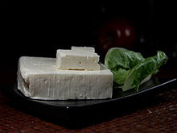
Feta cheese
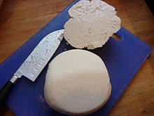
Mizithra
There is a wide variety of cheeses made in various regions across Greece. The vast majority of them remain unknown outside the Greek borders due to the lack of knowledge and the highly localized distinctive features. Many artisanal, hand made cheeses, both common varieties and local specialties, are produced by small family farms throughout Greece and offer distinct flavors atypical of the mass-produced varieties found commercially in Greece and abroad. A good list of some of the varieties of cheese produced and consumed in Greece can be found here. These are some of the more popular throughout Greece:
- Anthotyros
- Feta
- Formaela
- Graviera
- Halloumi
- Kalathaki
- Kasseri
- Katiki
- Kefalograviera
- Kefalotyri
- Kopanisti Mykonou
- Mastelo
- Myzithra
- Manouri
- Metsovone
- Saganaki
- San Michali

Non-alcoholic beverages
There is a variety of non alcoholic beverages that are drunk in Greece even to this day.
Portokalada (orangeade) and Lemonada (lemonade), since 1971, these beverages were served everywhere, in homes, cafes, tavernas and restaurants. They were made with fresh strained orange juice or lemon juice either mixed with carbonated water or flat mineral water and you added sugar to taste. There were also bottled local versions. In 1989 on the island of Rhodes there were two companies that made and bottled their own portokalada and lemonada using local oranges, lemons and water. These beverages are still standards today, as of 2014, the difference being that most of the small local companies sold their businesses to the big companies like Fanta etc., thus, greatly changing the quality.
Visinada (cherryade) is made from dark cherry syrup (which was originally homemade) mixed with cold water.

Coffee
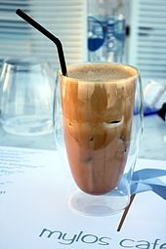
Frappé coffee
The traditional coffeehouses in Greece are called kafenia, and they offer coffee, refreshments, alcoholic beverages and snacks or meze. In recent years, especially in the large urban centres, kafenia are gradually being replaced by modern "cafeterias". Preferred types of coffee are, among others, Greek coffee, frappé (a foam-covered iced coffee drink), and iced cappuccino and espresso, named Freddo Cappuccino and Freddo Espresso, respectively.^{[16]} Iced coffee-based drinks, such as freddoccino or freddito, are also popular in the summer.

Tea and herbal teas
- Chamomile: chamomile tea
- Mint tea: right out of the garden
- Faskomilo (sage tea): tea made from dried or fresh sage
- Tsai vounou: tea from steeped mountain sage. To this day the Greeks still like to drink a tea made from steeping dried or fresh mountain sage
- Sideritis

Alcoholic beverages

Wine
For more details on this topic, see Greek wine.
The origins of wine-making in Greece go back 6,500 years^{[17][18]} and evidence suggesting wine production confirm that Greece is home to the oldest known grape wine remnants discovered in the world^{[19]} and the world’s earliest evidence of crushed grapes.^{[17]} The spread of Greek civilization and their worship of Dionysus, the god of wine, spread Dionysian cults throughout the Mediterranean areas during the period of 1600 BC to the year 1 AD.^{[20]} Greece's viticultural history goes back to prehistoric times,^{i[›]} and wine production was thriving until the 11th century.^{[21]} After World War II, Greek winemakers imported and cultivated foreign grape varieties, especially French ones, in order to support local production.^{[22]} In 1960s, retsina, a dry white wine with lumps of resin, was probably the most well-known Greek wine abroad. In recent years, local varieties are rediscovered and often blended with foreign ones.^{[23]} In early 1980s, a system of appellations, modelled on the respective French one, was implemented to assure consumers the origins of their wine purchases. Today, there are 28 appellations (Appellations of Origin of Superior Quality and Controlled Appellation of Origin) throughout the country, from Macedonia to Crete.^{[24]}
- 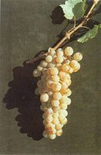
Assyrtiko grapes
- 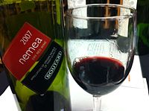
A Nemea wine made entirely from Agiorgitiko

Beer
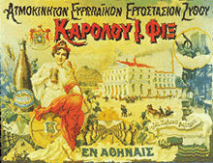
Advertisement for Fix beer, late 19th century
Archaeological and archaeochemical finds suggest that the Minoans fermented barley and other substances, and consumed some form of beer.The beer tradition of the Minoans was discontinued by the Mycenaeans; beverages from fermented cereals may have remained only in Crete during their rule. In Archaic and Classical Greece, beer is mentioned as a foreign beverage, while, when Alexander the Great conquered in 332 BC Egypt, a civilization with a long brewing tradition, the Greeks continued to disdain beer seeing it as the drink of their rivals In Modern Greece, a limited number of brands—owned by breweries from northern Europe in most cases (e.g. Heineken or Amstel)—dominated for many years the local market, while a stringent Bavarian-influenced beer purity law was in force.Gradually, the provisions of this law loosened, and, since the late 1990s, new local brands emerged (in 1997 Mythos made a breakthrough) or re-emerged (e.g. Fix Hellas), reviving competition. In recent years, in parallel with the large breweries, local microbreweries operate throughout Greece

THE BEST TAVERNS IN ATHENS-PLAKA

Strofi Tavern
· Greek
Classic Greek fare in a simple, airy space with a roof terrace for amazing Acropolis views.
Rovertou Galli,Athens,11742 25
Cosy · Locals · Groups

Klimataria
· Mediterranean
Home-style cooking in an intimate old-school rustic restaurant with stone walls & live Greek music.
Pl. Theatrou 2
Cosy · Casual · Locals

Platanos Taverna
· Restaurant· Diogenous 4
Cosy · Casual · Locals

Oinopoleion
· Restaurant
· Eschilou 12
Cosy · Casual · Locals

Kalokerinos
· Greek
Kekropos 10
Cosy · Casual · Locals

Karavitis
Greek
Pafsaniou 4
Cosy · Casual · Locals

Diporto
· Greek
Sokratous 9
Cosy · Casual · Locals

Bairaktaris
Greek
All-day souvlaki kebabs & hearty traditional Greek dishes served in a bustling, family-run taverna.
Pl. Monastirakiou 5
Cosy · Casual · Locals

ΤΑΒΕΡΝΑ ΤΟΥ ΨΥΡΡΗ
Greek
Eschilou 12
Cosy · Casual · Locals

Geros Tou Moria
· Restaurant
Traditional Greek dishes in cozy, rustic dining room with murals, plus outdoor tables beneath vines.
· Mnisikleous 27
Cosy · Casual · Locals

Restaurant Taverna Plaka
Restaurant
· Kidathineon 16
Cosy · Casual · Locals

Ταβέρνα Κληματαριά
· Greek
· Pl. Theatrou 2
Cosy · Casual · Locals

Σταματοπουλου Παλια Πλακιωτικη Ταβερνα - Stamatopoulos
· Greek
Classic Greek cuisine & music in a long-standing restaurant with rustic decor & wall paintings.
· Lisiou 26
Cosy · Casual · Locals

Παληα Ταβερνα Κρητικου - Old Taverna Kritikou
· Greek
Classic Greek cuisine in a rustic old-school venue with frescoes and a terrace with Acropolis views. · Mnisikleous 24
Cosy · Casual · Locals

